# LUCRAREA DE LABORATOR nr. 8

**Samciucov Valentin**

**Elemente combinaţionale: multiplexor, demultiplexor**

# Scopul lucrării:

1. Studierea elementelor combinaţionale (multiplexorul, demultiplexorul) în regim static.
2. Studierea elementelor combinaţionale (multiplexorul, demultiplexorul) în regim dinamic.

# Experimentul nr. 1. Multiplexorul

1. **Regim static.**

Tabel 1. Tabelul de adevar al multiplexorului din 8 in 1

|  |  |  |  |  |  |  |  |  |  |
| --- | --- | --- | --- | --- | --- | --- | --- | --- | --- |
| **E** | 0 | 1 | 1 | 1 | 1 | 1 | 1 | 1 | 1 |
| $$S_{2}$$ | X | 0 | 0 | 0 | 0 | 1 | 1 | 1 | 1 |
| $$S_{1}$$ | X | 0 | 0 | 1 | 1 | 0 | 0 | 1 | 1 |
| $$S_{0}$$ | X | 0 | 1 | 0 | 1 | 0 | 1 | 0 | 1 |
| **I** | 0 | $$I_{0}$$ | $$I_{1}$$ | $$I_{2}$$ | $$I_{3}$$ | $$I_{4}$$ | $$I_{5}$$ | $$I_{6}$$ | $$I_{7}$$ |

Functia logica a multiplexorului din 8 in 1:

I = $EI_{0}\overline{S_{2}S_{1}S_{0}}+EI_{1}\overline{S_{2}S_{1}}S_{0}+EI_{2}\overline{S_{2}}S_{1}\overline{S_{0}}+ EI_{3}\overline{S_{2}}S_{1}S_{0}+EI_{4}S_{2}\overline{S_{1}S_{0}}+EI_{5}S_{2}\overline{S_{1}}S_{0}+EI_{6}S_{2}S_{1}\overline{S_{0}}+EI_{7}S_{2}S_{1}S_{0}$

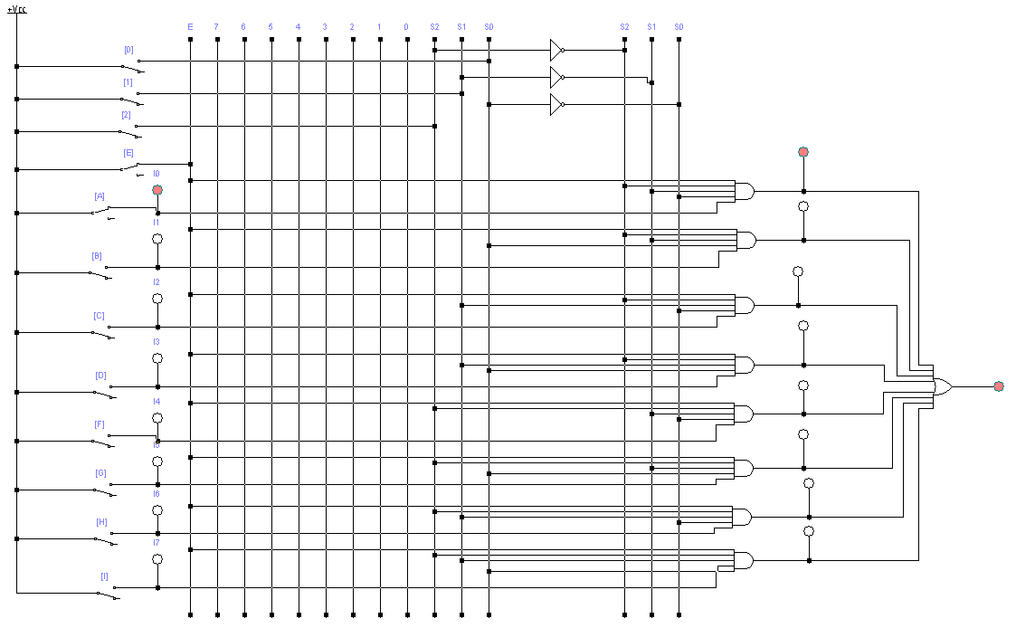

Fig. 1. Schema electrica a multiplexorului (regim static)

1. **Regim Dinamic**

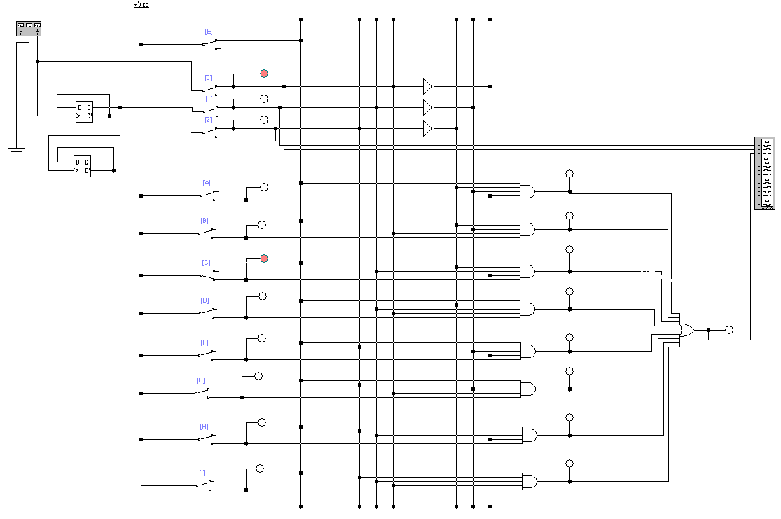

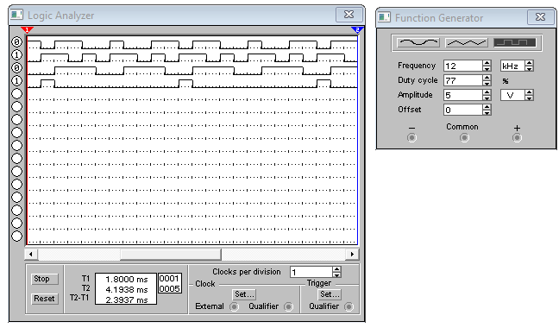

Fig. 2. Schema electrica a multiplexorului (regim dinamic)

**Experimentul nr. 2. Demultiplexorul**

1. **Regim static.**

Tabel 2. Tabelul de adevar al demultiplexorului din 1 in 8

|  |  |  |  |  |  |  |  |  |  |
| --- | --- | --- | --- | --- | --- | --- | --- | --- | --- |
| E | 0 | 1 | 1 | 1 | 1 | 1 | 1 | 1 | 1 |
| $$S_{2}$$ | x | 0 | 0 | 0 | 0 | 1 | 1 | 1 | 1 |
| $$S_{1}$$ | x | 0 | 0 | 1 | 1 | 0 | 0 | 1 | 1 |
| $$S_{0}$$ | x | 0 | 1 | 0 | 1 | 0 | 1 | 0 | 1 |
| $$I_{7}$$ | 0 | 0 | 0 | 0 | 0 | 0 | 0 | 0 | I |
| $$I_{6}$$ | 0 | 0 | 0 | 0 | 0 | 0 | 0 | I | 0 |
| $$I_{5}$$ | 0 | 0 | 0 | 0 | 0 | 0 | I | 0 | 0 |
| $$I_{4}$$ | 0 | 0 | 0 | 0 | 0 | I | 0 | 0 | 0 |
| $$I_{3}$$ | 0 | 0 | 0 | 0 | I | 0 | 0 | 0 | 0 |
| $$I_{2}$$ | 0 | 0 | 0 | I | 0 | 0 | 0 | 0 | 0 |
| $$I_{1}$$ | 0 | 0 | I | 0 | 0 | 0 | 0 | 0 | 0 |
| $$I_{0}$$ | 0 | I | 0 | 0 | 0 | 0 | 0 | 0 | 0 |

Functia logica a demultiplexorului din 1 in 8:

I7 = ;

I6 = ;

I5 = ;

I4 = ;

I3 = ;

I2 = ;

I1 = ;

I0 = ;

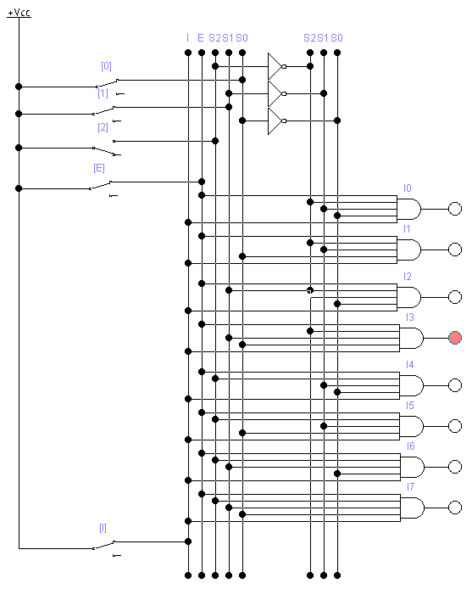

Fig. 3. Schema electrica a demultiplexorului (regim static)

1. **Regim Dinamic**

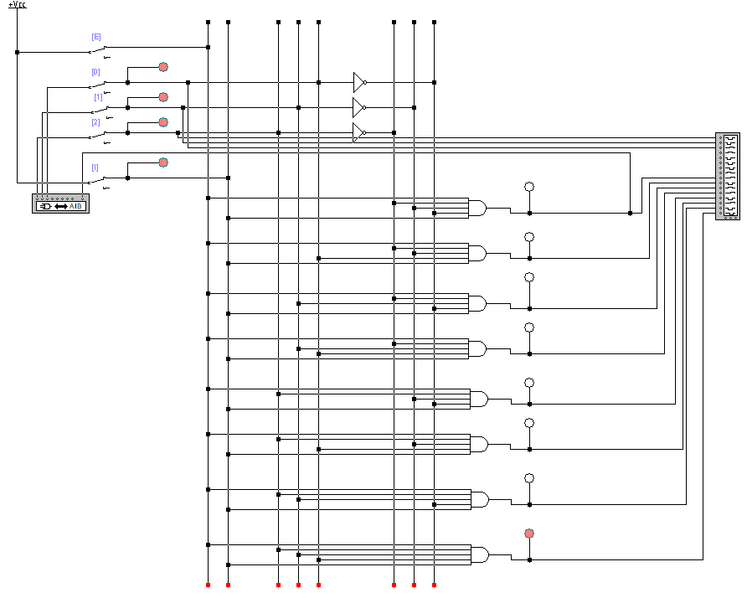

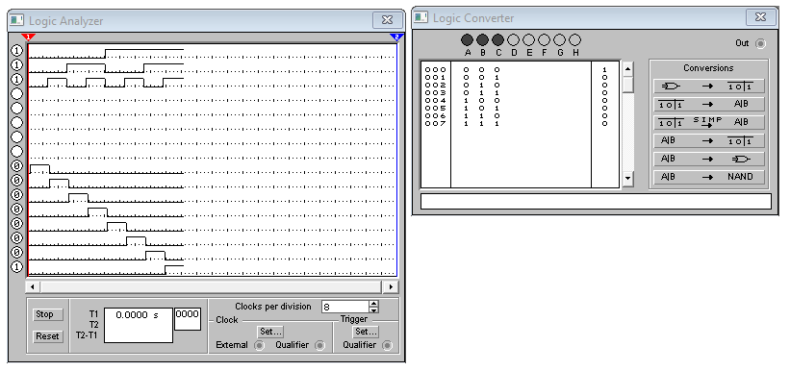

Fig. 4. Schema electrica a multiplexorului (regim dinamic)